NCL – AWS Outpost POC
Shipboard Network

POC Objectives
Validate the possibility of using AWS Outposts as a replacement for VMware on the ships.

What is AWS Outpost?
AWS Outposts is a fully managed service that extends AWS infrastructure, services, APIs, and tools to customer premises. By providing local access to AWS managed infrastructure, AWS Outposts enables customers to build and run applications on premises using the same programming interfaces as in AWS Regions, while using local compute and storage resources for lower latency and local data processing needs.

An Outpost is a pool of AWS compute and storage capacity deployed at a customer site. AWS operates, monitors, and manages this capacity as part of an AWS Region. You can create subnets on your Outpost and specify them when you create AWS resources such as EC2 instances and subnets. Instances in Outpost subnets communicate with other instances in the AWS Region using private IP addresses, all within the same VPC.

Network Implementation
For the POC, two AWS Outposts Racks were deployed on Miami Office Datacenter. To provide connectivity, it was required to us to extend DiscoveryLab ACI fabric to Miami Office using two remote Leaf switches.

The following is the topology used to configure ACI Remote Leaf.

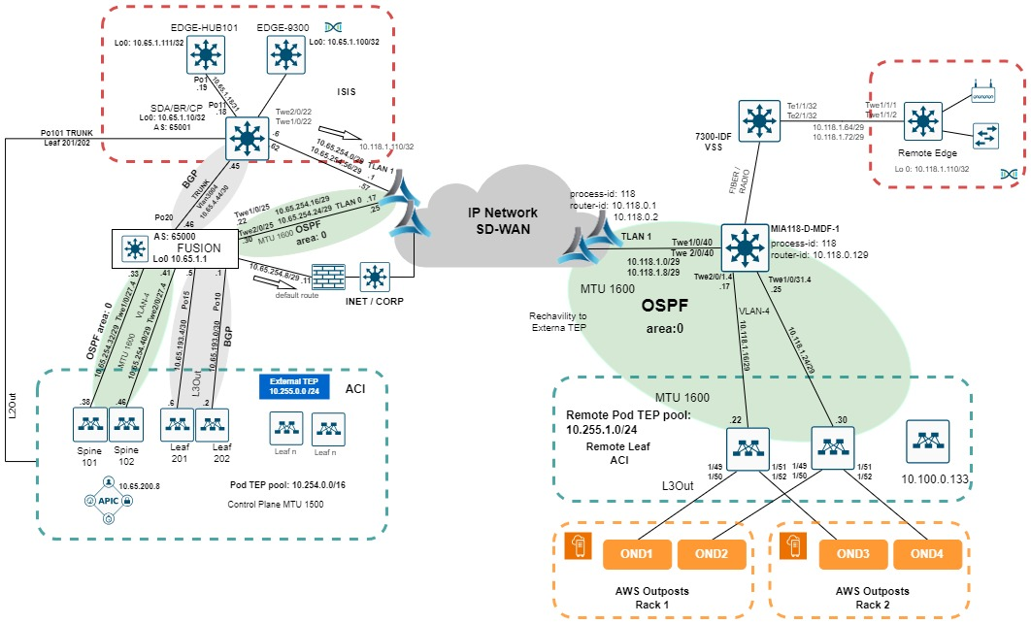

The following picture shows the DiscoveryLab level 3 topology with AWS Outposts.
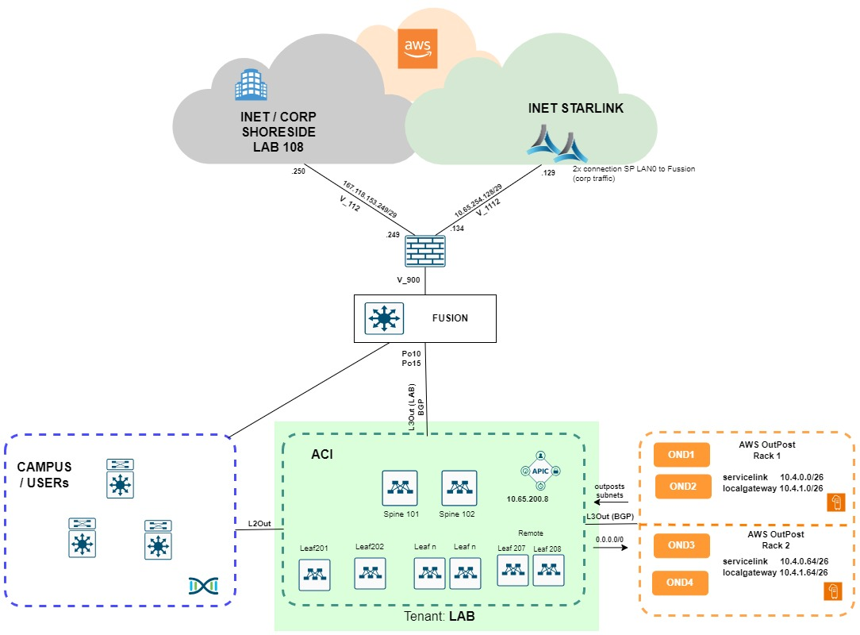

VPC Configuration
For the testing, one VPC, CIDR 10.65.144.0/21 this will allow us to configure 8 x /24 subnets. Currently 10.65.149.0/24 and 10.65.150.0/24 are created.

If you need to create new subnets you must follow the following steps:
- Add the subnets on the ACI L3Out: L3_OUT, External EPG: op-bgp-localgateway-extEPG, as shown in the following picture.
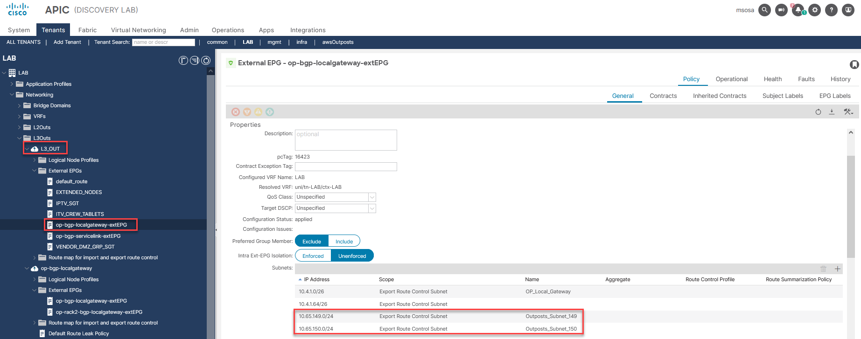

- Add the subnets on the ACI L3Out: op-bgp-localgateway, External EPGs: op-bgp-localgateway-extEPG or op-rack2-bgp-localgateway-extEPG depending on subnet rack assignment. The following picture shows the configuration of subnet 10.65.149.0/24 for Rack-A.

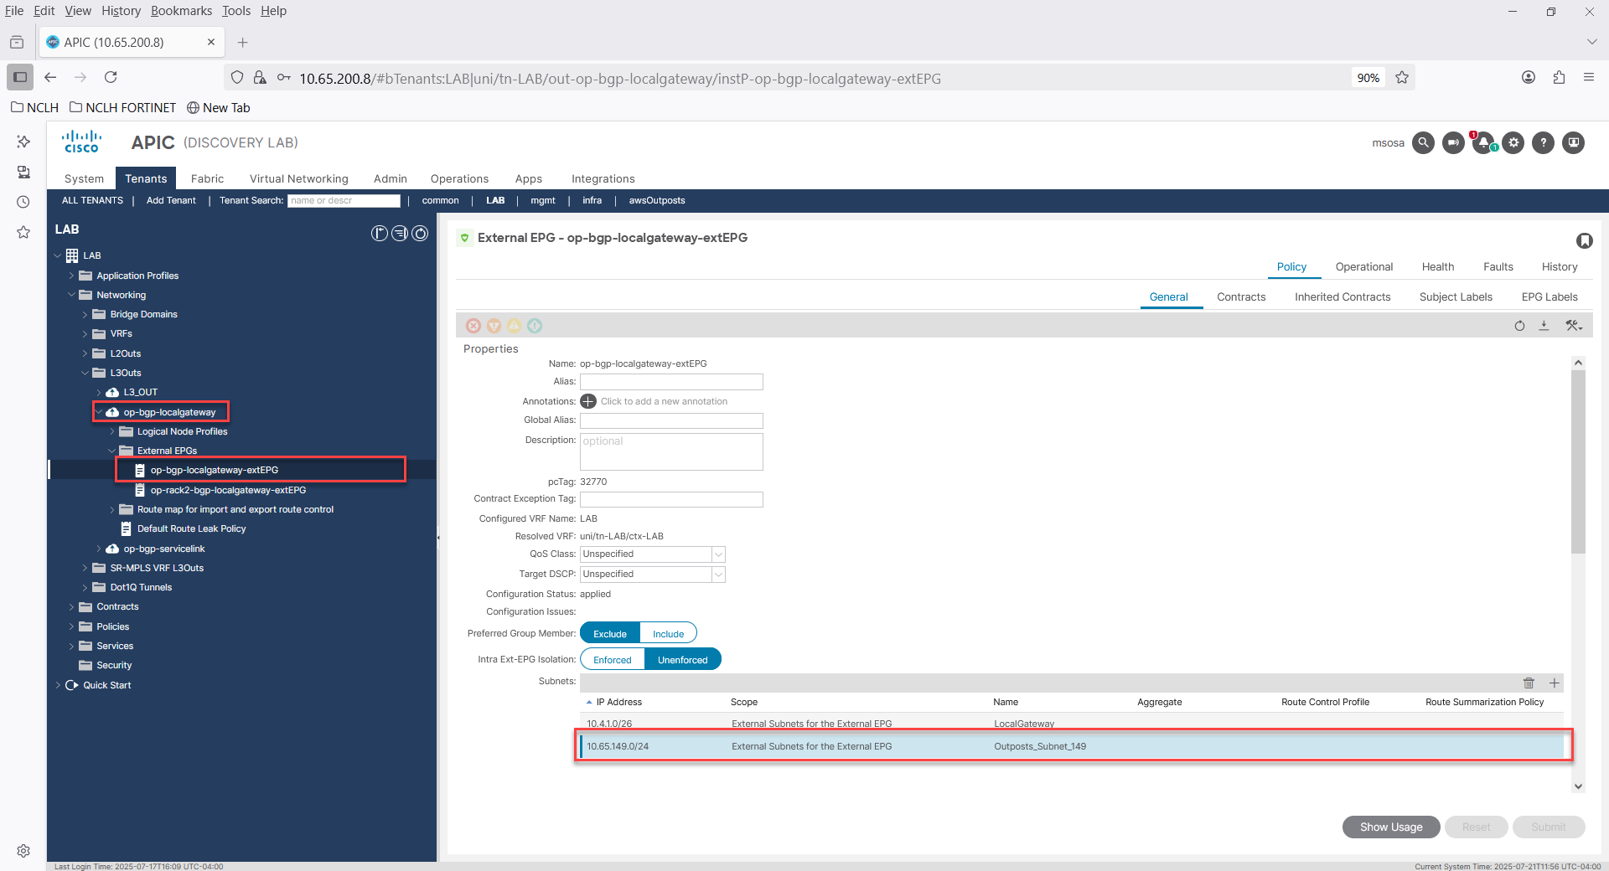

- Create the subnets on the AWS Outposts Console, this procedure is different than to create the subnet on a regular VPC. The following document explains this step.

Troubleshooting
- Verify on Fusion that the new subnets have been advertised.
- Ask Cloud Team to deploy a temporal EC2 on the new subnet to test connectivity from outside AWS Outposts.

WAN Connectivity
Outposts traffic is over DiscoveryLab terrestrial 500Mbps links. There is another project to migrate DiscoveryLab to Starlink connectivity, still under review. For connectivity requirements please check AWS Outposts documentation.

